100 Years of Electrical Imaging
Hervé Chauris¹, William R.B. Lionheart², and Andy Adler³
¹Mines ParisTech, France
²University of Manchester, UK
³Carleton University, Ottawa, Canada

Abstract: This is the template file for the booklet given to the participants during the workshop “100 years of electrical imaging”, which will be held in Paris, July 9-10, 2012. Please use the Latex template or the accompanying Word format template when preparing your submission. The templates are available in electronic form at the website: http://100electrical.geosciences.mines-paristech.fr. Thanks!

Introduction
In 1912, Conrad Schlumberger (1878-1932), professor at the Ecole des Mines de Paris (now MINES Paristech), made the first electric field imaging experiment at his family house in Val Richer, in Normandy. This offered new possibilities for exploring the Earth. Over the last 100 years, electrical imaging has grown to be used in many other fields such as medical and process tomography

To celebrate this innovation, a workshop will be held with the goal of
- Celebrate the 100th anniversary of the first electrical imaging experiment
- Bring together the disparate electrical imaging communities (geophysical, medical and industrial process imaging, as well as other specialist applications)
- Encourage interactions and knowledge transfer between the communities on image analysis and algorithm techniques

This is a Word template document for the workshop on ``100 years of electrical imaging", to be held in Paris, July 9 – 10, 2012.

1.1 Abstract
Each paper should contain an abstract of about 100-200 words that appears at the beginning of the paper.

1.2 Figures
All figures should be centered. Figure captions should follow each figure and have the format given in the example. The easiest way to position figures and captions in MSWord (read: “the least difficult way”) is to use the “square wrapping style.” Turn off “move object with text” and turn on “lock anchor,” after making sure that the anchors of the figure and of its caption are located in exactly the same position. Another possibility is to insert a “text box” and then place the figure inside it.
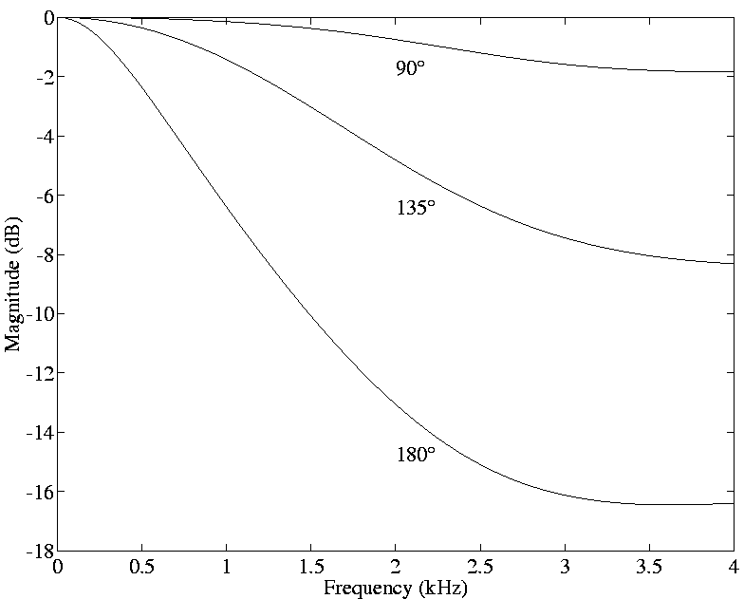

Figure 1: figure inside textbox

1.3 Equations
Equations should be placed on separate lines and numbered:
$W_{\text{WF}}=X^{−T}⋅\text{diag}\left\{\frac{σ_{i}^{2}−η_{i}^{2}}{σ_{i}^{2}}\right\}⋅X^{T}\text{.}$ (1)

Tables
The table caption should be below the table.

References
List and number all references at the end of the paper. The references can be numbered in alphabetic order or in order of appearance in the document. Use reference numbers in square brackets as shown at the end of this sentence [1] [3]. The reference format is the standard IEEE one [2]. Check reference numbering before you submit your paper.

Conclusion
This template can be downloaded from the conference website:
http://100electrical.geosciences.mines-paristech.fr

References
- R. F. Lyon and C. Mead, “An Analog Electronic Cochlea”, IEEE Trans. ASSP 36: 1119-1134, 1988.
- Lee, K.-F., Automatic Speech Recognition: The Development of the SPHINX SYSTEM, Kluwer Academic Publishers, Boston, 1989.
- Y. Sjokolati and J. J. Marzipani, “A new Recipe for the Preparation of Sweets for General Consumption”, in Proc. of the 1998 Int. Conf. On Food, Drinks and Sweet Processing, New York, pp. 470-473, April 1998.

